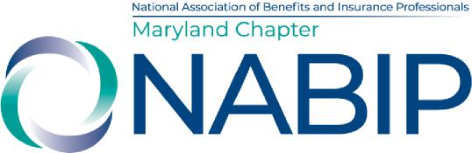
NABIP-MD May Board Meeting
May 12, 2026
AGENDA

- Call to Order – Melissa
- Bryson, Joan, Glenn, Kevin, Jon - State Leg update
- Introduction of Laurie and Ashley to the board as possible board members
- Minutes – approve April
- Financials – review and approve April – Michele/Melissa
- 2026 – 2027 Planning Meeting in June
- Annual Expo
  - New location – Martin’s West June 16
  - Golf with Carriers in Fall – September 25th at Waverly Woods
  - Email Blast with changes – Sent to current sponsors
  - Increase Sponsors – We only have 11!
  - Contact Speakers – We only have three CE’s – not enough for breakout sessions
  - Increase registrants – We only have 32
  - Signs
  - Nametags and Ribbons
- New Business
  - Website updates
  - Event Board Position
  - Board Positions
  - Medicare Summit – August 5th
- Adjourn

